**iNEURON POWER BI ASSIGNMENT-1**

1. **Install Power BI Desktop and share the final screenshot of the report view page which appears when power desktop starts.**

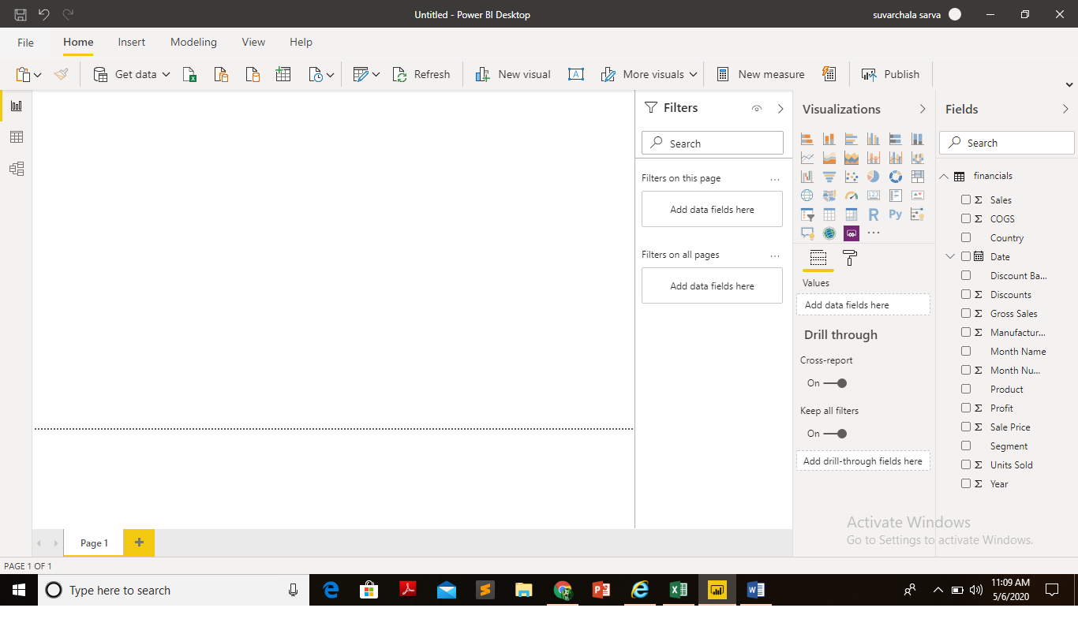

1. **Prepare a document and with the following screenshot**

* **Report View**
* Power bi desktop has three main views available on it at the left side of the canvas.
* They are namely Report View, Data View and Model View.
* Here, Report view is a pane on the canvas where visuals are dropped and reports are created. Any number of visuals can be added and reports may be added via creating pages which later published to report server.

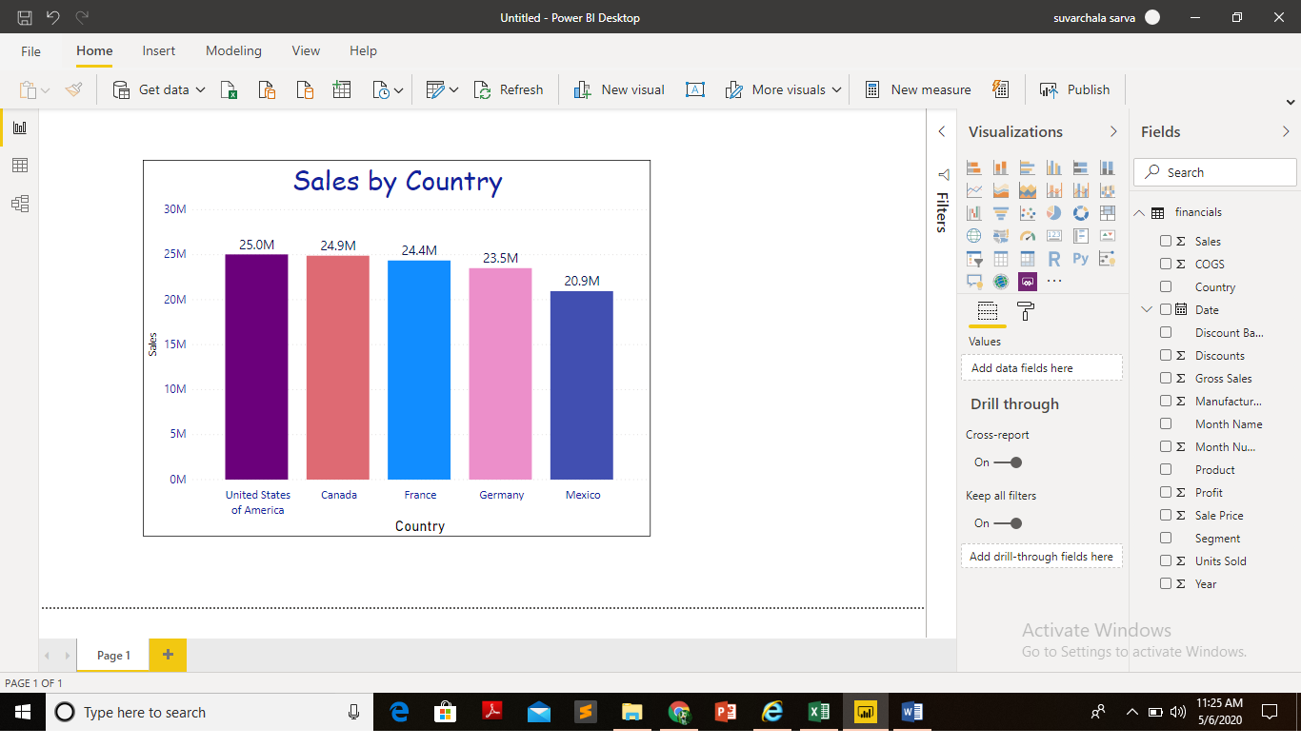

* **Data View**
* Data View is a pane on the canvas, where the data in form of table is shown.
* Developer or admin can have look at the data and transform data , then observe the immediate changes like basic removal of top rows etc, conditioned filters.
* Complete fields detailas and count of records can be known in the data view.

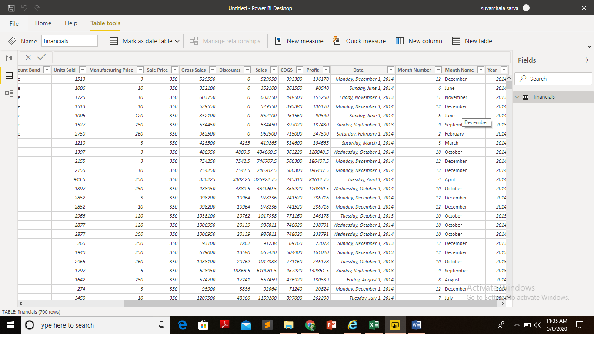

* **Model View**
* In the model view of the pane on canvas, relationship between different tables that are available in database are shown.
* One can study the existing relationships among the tables, create new relationships and build a model.

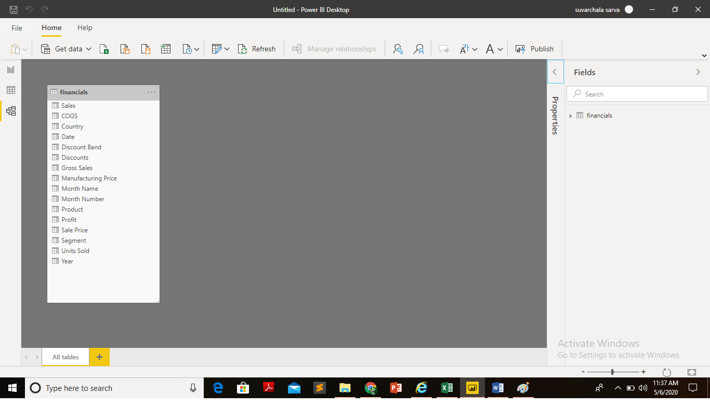

* **Power Query Editor**
* In Power BI Desktop, one can transform data using power query editor.
* Can make changes to data, such as changing a data type, removing columns, or combining data from multiple sources, replace data values, adding new required calculated columns, apply statistical measures to data etc.
* Most crucial part of tool to perform transformations on data which helps in eliminating unwanted data values and encourages visualizations on the cleansed data.

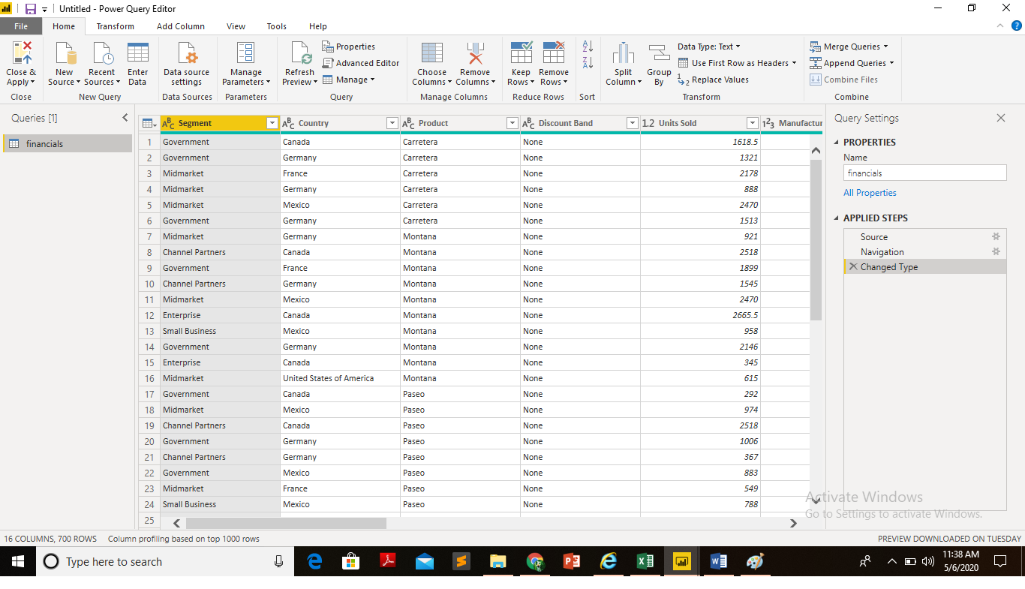

* **Advance Editor**
* The **Advanced Editor** lets you see the code that Power Query Editor is creating with each step.
* can directly edit the code in the **Advanced Editor** window

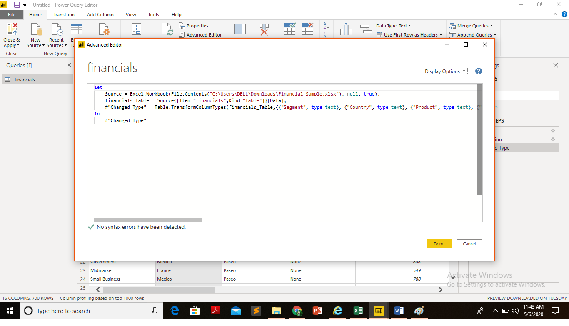

1. **Prepare a document with details of the following along with their price**

Power BI is robust visualization tool provided by Microsoft which eases end user understanding the data in the form of beautiful visuals. No need to understand tedious numbers and calculations, just by observing the visual, many things are understood. It is collection of software services, apps and connectors that work together to convert data into visuals.

* **Power BI Desktop**
* Power BI Desktop is free application that is installed on local machine which lets you to connect, transform and visualize data. Reports are created in Power BI Desktop and are published to Power bi service using Power bi report server.
* Power BI requires that you use a work or school email address to sign up. You can't sign up using email addresses provided by consumer email services or telecommunication providers. This includes outlook.com, hotmail.com, gmail.com, and others. If you don't have a work or school account, [learn about alternate ways to sign up.](https://docs.microsoft.com/en-us/power-bi/service-admin-signing-up-for-power-bi-with-a-new-office-365-trial)
* **Power BI Pro**
* In the Power BI service, users have defined capabilities based on the type of per-user license they have and whether the content they are acting on is in a workspace assigned to a Power BI Premium capacity.
* Per-user - Power BI Pro and Power BI (free) licenses. A Power BI Pro license enables a user to collaborate with other Power BI Pro users by consuming content from, and sharing content with other users with a Power BI Pro license. Only users with a Power BI Pro license can publish content to app workspaces, share dashboards, and subscribe to dashboards and reports. A free license enables a user to consume content in a workspace assigned to a Power BI Premium capacity and access to some of the features of the Power BI service for their own personal content in their My Workspace.
* Free Trial period is for 60 days and after its expiry, Power BI Pro has to be purchased to get access for its flexible resources , price is $9.99(in US Dollars) and Rs. 660.00(in Indian currency) monthly per user.
* **Power BI Premium**
* You can use Power BI Premium to get dedicated and enhanced resources for your organization, so users in your organization can use the Power BI service with better performance and responsiveness.
* With a Power BI Premium subscription, you and your organization's users get access to:
  + Greater scale and performance
  + Flexibility to license by capacity
  + Unify self-service and enterprise BI
  + Extend on-premises BI with Power BI Report Server
  + Support for data residency by region (Multi-Geo)
  + Share data with anyone without purchasing a per-user license
* Power BI Premium is a tenant-level Office 365 subscription available in two SKU (Stock-Keeping Unit) families

**P** SKUs (P1-P5) for embedding and enterprise features

**EM** SKUs (EM1-EM3) for *organizational* embedding, requiring a yearly commitment, billed monthly

* Power BI Premium capacity - Power BI Premium licensing. Power BI Premium provides dedicated capacity to deliver more consistent performance and support larger data volumes in Power BI. Power BI Premium also enables widespread distribution of content by Pro users without requiring users who view the content to have Power BI Pro licenses.
* Large datasets, Incremental refresh, paginated reports, unlimited content sharing, etc. are some special features with Power BI Premium.
* Monthly price per dedicated cloud compute and storage resource with annual price for Power BI Premium is Rs. 3, 30, 190(in Indian currency) and $4,995(in US Dollars).